## TINST 312 B: Computer Networks & the Internet

**Lab 1: Create a Personal Web Page**

Create a page named <yourname>.html (Mine would be derek.html) that describes you. Use Notepad++ if you can. It is installed on the lab computers and easy to download on any Windows machine. If using a Mac is absolutely necessary, use Atom to create your HTML file. Instructions will be similar.

1. Launch Notepad++ and type in the html code as shown below.
2. Save your page as “yourname.html”. If the save icon next to the file name is shown in red (as shown below), your page needs to be saved. Hit the floppy (save) button once you see the filename.html as seen below. You will need to keep saving it after you make changes.

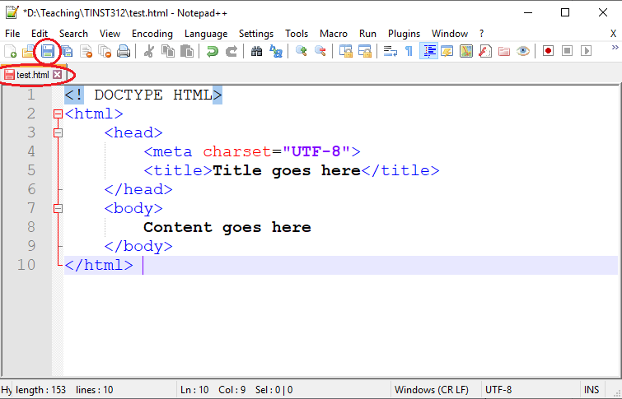

1. Once saved, you can locate the file on your hard drive and double click it to launch it in a browser or go to “Run -> Run” (or press F5) in Notepad++ and then choose the browser you want to use.
2. On your page, include all of the following information (using tags):

* Your name.
* A description of yourself in three sentences or less. Emphasize the most important word(s) by putting them in bold or italics.
* A list of classes you are taking right now at UW.
* Your 3 favorite movies, books, or TV shows, in order. Make at least one link to an interesting site about that TV show/movie/book, such as its [IMDB](https://www.imdb.com/) page or fan page.
* Two images, one that represents you when you're happy and the other to represent you when you're sad. (These can be any images you like. Consider searching for images on [Google Image Search](https://images.google.com/))
* Something interesting about one or more of your neighbors (people sitting at computers next to you).

***It’s best to do the above in small steps and test that your web page displays correctly.*** Here’s what mine looks like if you need an example:

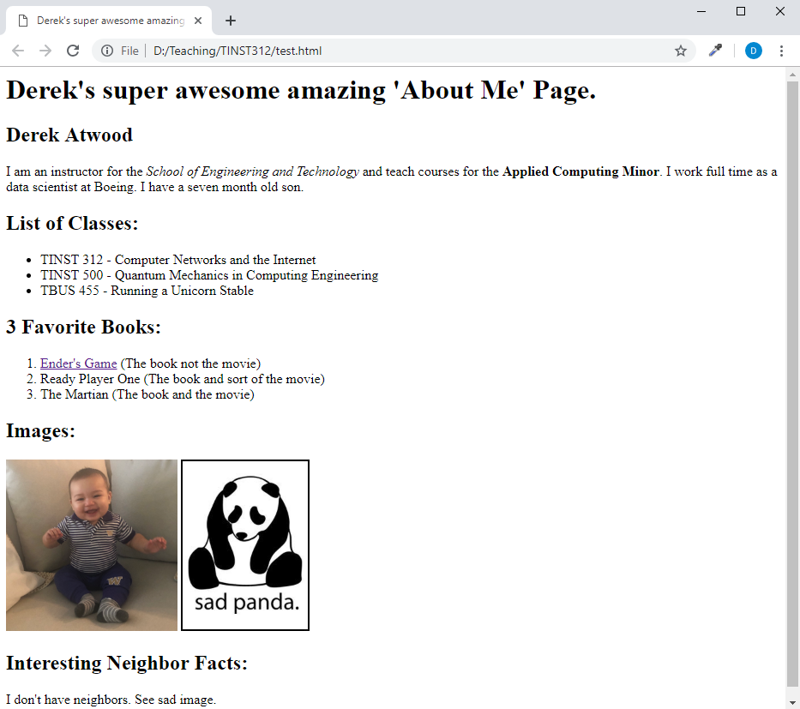

**Want to Learn More? Validate Your Web Page**

Go to <http://validator.w3.org>